ADVISORY BOARD ON COSMETOLOGY
Meeting of February 10, 2020
North Campus Building, 1st Floor Public Meeting Room
1106 Clayton Lane, Austin, Texas

Summary of Minutes

Presiding Officer, Ron Robinson, called the meeting to order at 1:35 p.m.

Presiding Officer, Ron Robinson, called roll. Board members present were Ron Robinson, Natalie Inderman, Betty Chelle Neff, Aleshia Rivera, Sam Webb and Mary Paschal-Lindsay. Board members Anthony Anderson, Claudia Avalos, Vanessa Robbins, and Debbie Wieland were absent. A quorum was present.

Presiding Officer, Ron Robinson, moved to agenda item C., Approval of minutes - Meetings of November 18, 2019. Board member, Sam Webb, seconded by Mary Lindsay, made a motion to approve the minutes as presented. The motion passed by a unanimous vote.

Presiding Officer, Ron Robinson, moved to agenda item D., Public Comment. Oscar Perez, Rebecca Yandell, Laura Valdez, Erin Poff, Sharla Wooten, and Kim Moyers gave public comment.

Presiding Officer, Ron Robinson, moved to agenda item E., Staff Reports. Yvonne Lopez, Licensing Manager, provided the Licensing Division report. Jacqueline Rush, Manager, provided the Customer Service Division report. Rebecca Armas, Education and Examination Liaison, provided the Education and Examination Division report. Victoria Meza, Prosecutor, provided the Enforcement Division report. Elizabeth Perez, Program Specialist, provided the Regulatory Program Management Division report. Juan Munoz, Field Inspections Liaison, provided the Field Inspections Division report. David Gonzales, Deputy Executive Director, provided the Executive Office report.

Presiding Officer, Ron Robinson, moved to agenda item F., Discussion and possible recommendation on the proposed new rules and amendments to existing rules at 16 Texas Administrative Code (TAC), Chapter 83, regarding the Cosmetology program. The proposed new rules and amendments implement necessary changes as required by the 86th Legislature, Regular Session (2019), and the passage of House Bill (HB) 2847. HB 2847 lowers the number of hours required to obtain a Cosmetology Operator License from 1,500 to 1,000 hours; clarifies the scope of work for certain licenses; increases the inspection cycle for certain establishments; and provides for the regulation of remote service businesses and remote services. The proposed new rules and amendments include proposed recommendations for the Advisory Board to consider for lowering the hours required to obtain a Cosmetology Operator License from 1,500 to 1,000. The proposed new rules and amendments include recommendations from the Advisory Board Workgroup to streamline the Cosmetology Program, provide clarity and remove regulatory burdens. This agenda item includes discussion of the public comments received on the proposed rules. Collene Tran, Assistant General Counsel, Rebecca Armas, E&E Liaison, and Marinela La Fleur, Program Specialist, spoke on this item. Board Member, Betty Neff, seconded by, Mary Lindsay, made a motion to approve the proposed rules and forward them to the Commission for adoption. The motion passed with unanimous vote.

Presiding Officer, Ron Robinson, moved to agenda item G., Recommendations for agenda items for the next Advisory Board meeting. The Board has added an update on the rule implementation, and an update on any workgroup discussions to the next agenda.

Presiding Officer, Ron Robinson, moved to agenda item J., Discussion of date, time and location of next Board meeting. Staff will poll the Board for a date in September 2020.

Presiding Officer, Ron Robinson, moved to agenda item K., Adjournment. The meeting adjourned at 3:10 p.m.

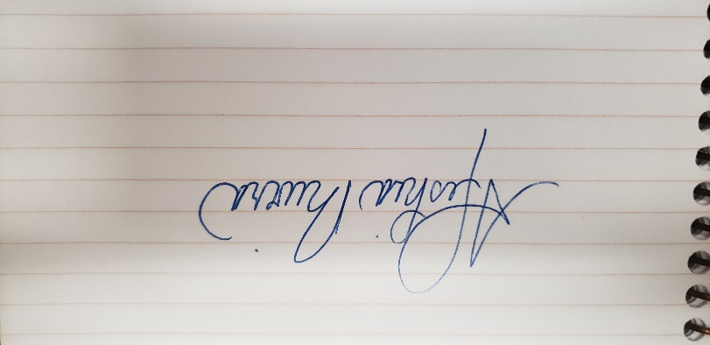
Aleshia Rivera, Presiding Officer Advisory Board on Cosmetology

